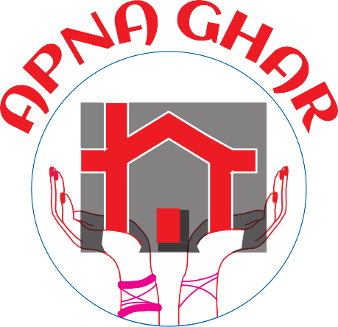ANNUAL
2021/2022
REPORT

2021/2022

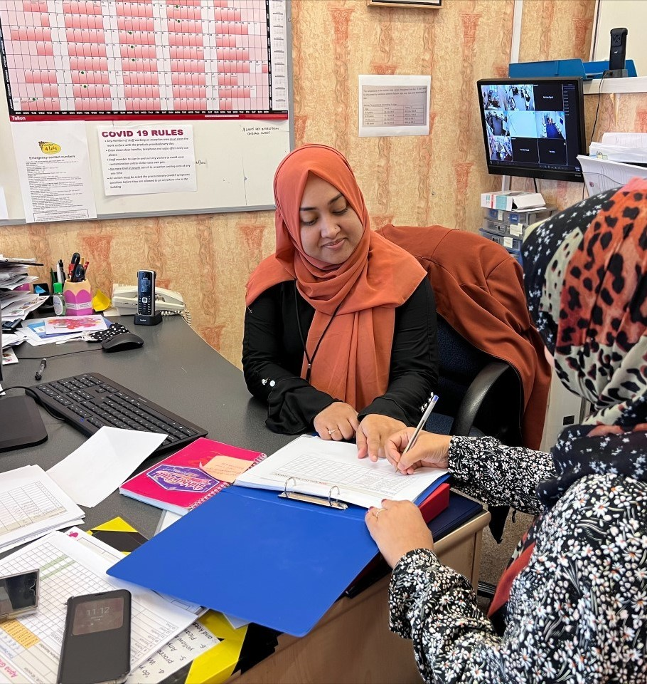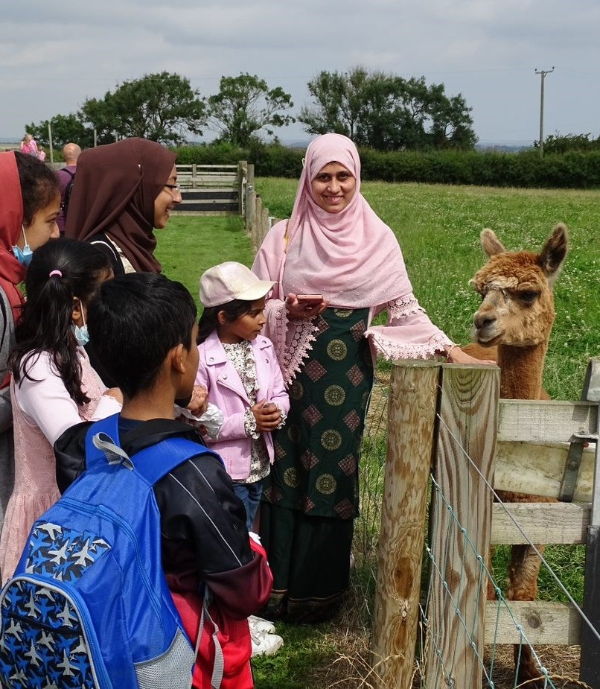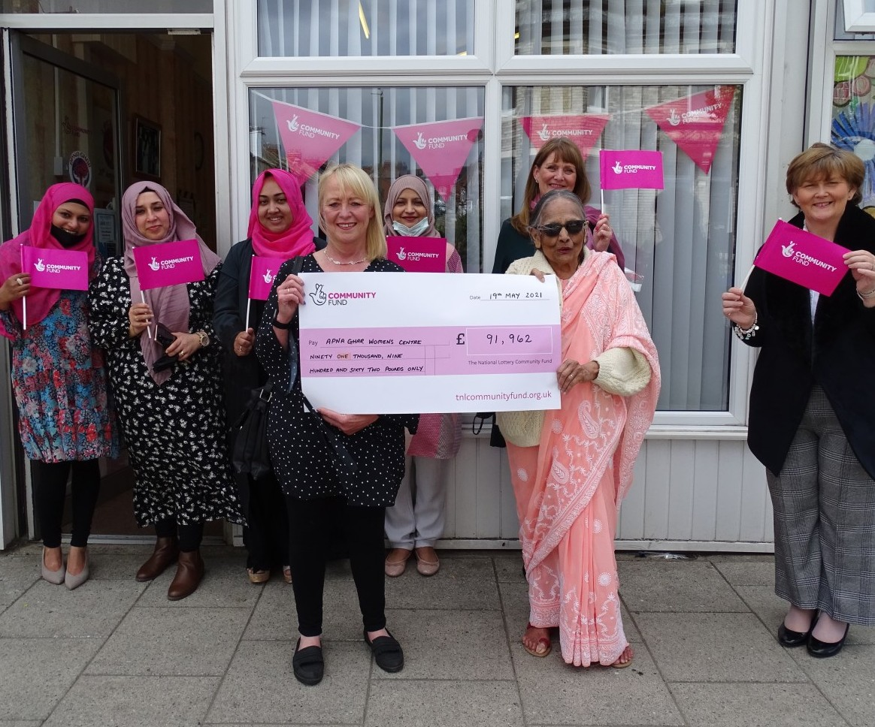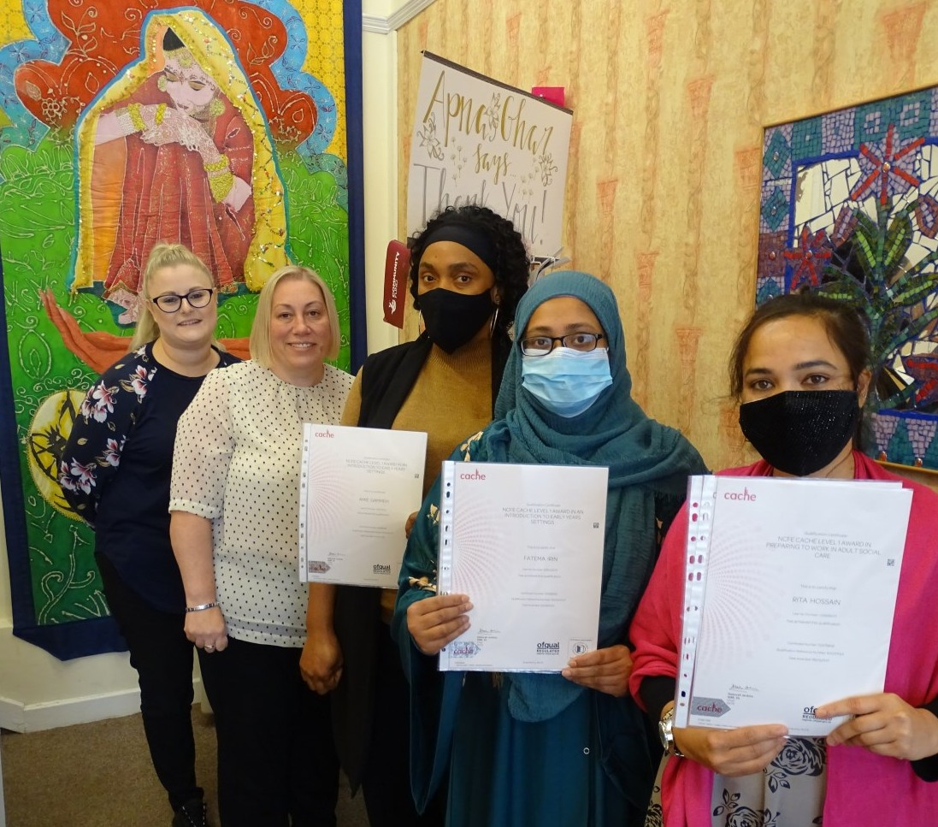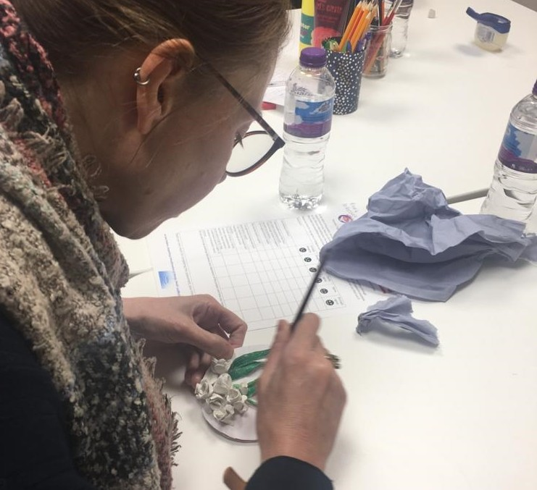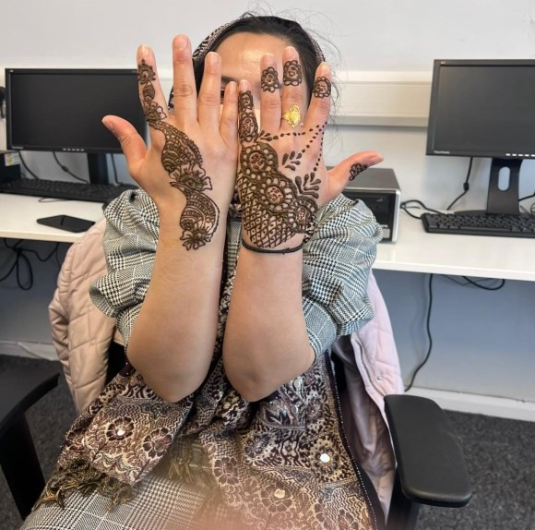AWARENESS THROUGH
Apna Ghar
ART

Page 7
CARING
FOR CARERS
CARING
FOR CARERS
Page 4-5
Page 4-5

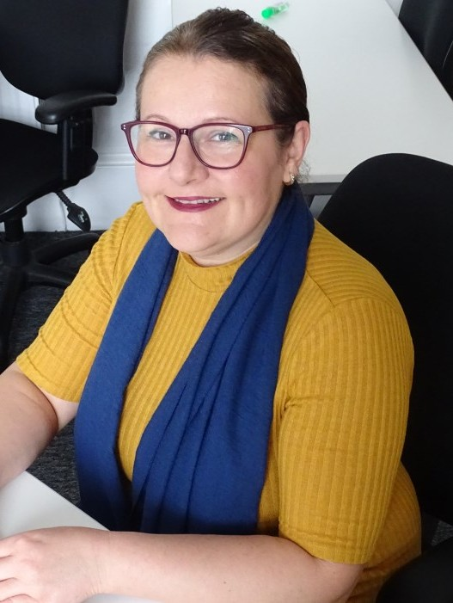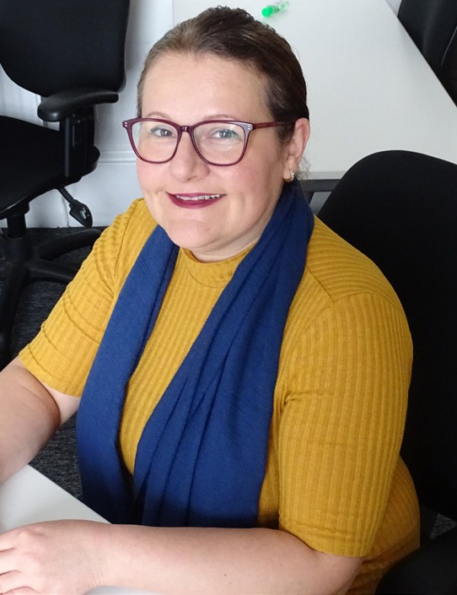The

Dr Otilia Popescu MD

CHAIR

Reports

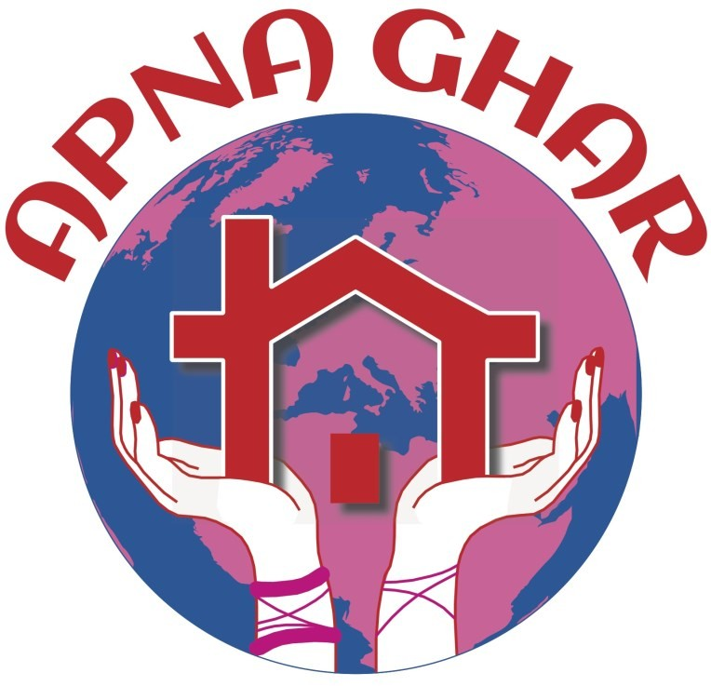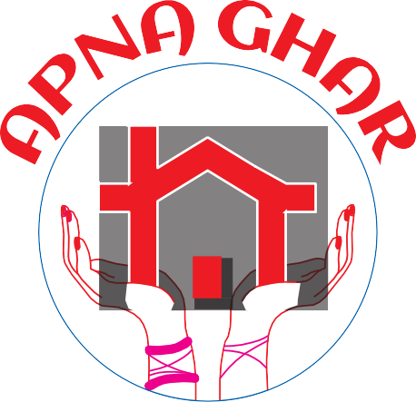It has been an honour to have been elected Chair of Apna Ghar Minority Ethnic Women’s Centre in 2021 – 2022. As we emerged from the Covid pandemic, we face the challenges of a world where there is more domestic violence and mental health problems, more poverty, and more child abuse, but also a wish to come together, to meet with friends and family and to live as normal. We have seen this
DDrr OOtitilliiaa PPPPooppeesscc MMDD
MANAGEMENT
BOARD
Members
Otilia Popescu - Chair Saira Malik - Deputy Chair Amina Hyder - Treasurer
Surajah Hunter - Deputy Treasurer Elaine Crompton - Secretary Kishwar Haque - Member
Asia Rahman - Member
Shobha Srivastava MBE - Member

The Apna Ghar Centre team
Susan Stevenson - Projects Coordinator
Nasrin Begum - Finance and Family Support
Shellina Begum - Finance/ Community Support/ Domestic Abuse
Farida Ansari - Community Support/Domestic Abuse
Akhi Azad - Community Support Rajwant Kaur - Domestic Abuse Officer
Naiema Ali - Admin Assistant Drupy Senanayake - Volunteer Lead Huda Alnajjar - Community Support
reﬂected in the activities that the Centre managed to provide
throughout the past financial year. Thanks to our funders we continued to oﬀer support to women from ethnic minorities living in South
Tyneside. Our Domestic Abuse project continued and thanks to funding from Comic Relief we became involved in a partnership project aimed at promoting health and wellbeing, as
well as awareness of Domestic Abuse for BAME women across the borough. We started our Carers’ project, which is currently ongoing, and we hope to oﬀer training and work opportunities to women who may be already carers for family members and now can access further education and work opportunities. We also set up a support group to care for women who are unpaid carers, caring for loved ones with physical or mental health problems at home. Our Luncheon Club continued, improved and became an opportunity for women from diﬀerent backgrounds to meet and share their love of food and good cooking, as well as to improve their language skills. Our health promotion
activities continued through education sessions as well as our fitness programme. We invited health professionals into our Luncheon Club and carers’ sessions, and encouraged women to eat healthier alternatives through our Luncheon Club. Our Sewing Class proved popular once more, with women learning a new skill, as well as having the opportunity to practice their spoken English and numeracy. ESOL classes are always in demand across the borough and we are pleased to have held three classes per week, as well as a conversation class for those aspiring to enrol onto our Carers’ courses. I would like to
thank the staﬀ who go above and
beyond doing their duty, always with a smile on their faces, to the Coordinator who keeps the team
together and ensures that all activities are on track, to our volunteers, and to the Board members who supported me throughout. And, last but not
least, a huge ‘Thank you’ to our funders: Comic Relief, The National Lottery, Police Crime Commissioner’s fund, Community Foundations of Tyne and Wear and Northumberland and Durham, South Tyneside Council, Ballinger Trust, Garfield and Weston Fund, Lloyds Foundation, Coalfields
Regeneration and Rise North East, and many others who appreciate the work we do. Their support is paramount, and we could not help the minority
women of South Tyneside without their help.

Dr Otilia Popescu MD

It is our MISSION

Apna Ghar is a Minority Ethnic Women’s Centre, based in the heart of South Shields.
By providing a wide range of opportunities the charity aims to develop confidence and empower women to recognise their full potential whilst allowing them to maintain their cultural identity.

Our strategic aims include:

- Enhancing awareness of the range of opportunities and services provided by
Apna Ghar
- Extending the number of
users who utilise the services provided by Apna Ghar
- Promoting and developing eﬀective links with the community between a wide range of organisations,
groups and individuals
- Oﬀering a range of vocational and non-vocational training opportunities
- Respecting and valuing the diversity of cultures

- & our objectives are:

- To provide outreach and link workers support to the community
- To actively promote the services of Apna Ghar to the community of South Tyneside
- To provide a culturally supportive and safe meeting place
- To make the services more accessible to the senior citizen members of the community

The project coordinator reports...

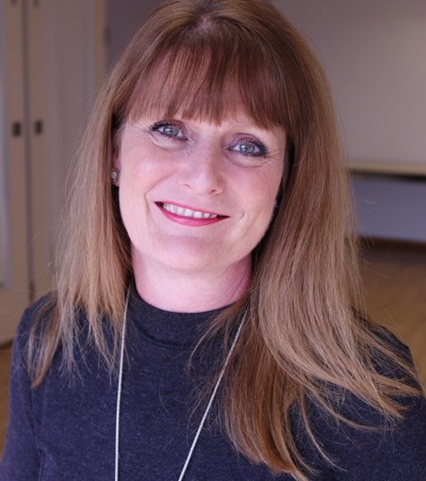
Sharing our
VISION
Apna Ghar was established more than 35 years ago with a vision as strong today as it was all those years ago.
As the only Minority Ethnic Women’s Centre in
South Tyneside ...
AEthnic Women. It has
pna Ghar’s vision is to
remain a leading supplier of services for Minority
the aim to enhance the services
provided by continually reviewing
and understanding the needs of its members.

Apna Ghar has a commitment to funders, clients, members and the community in which it serves. In the following pages, we look at some of the ways Apna Ghar has been transforming words into actions over the past year.
Apna Ghar wants you to know how they work and what a diﬀerence it makes to the women of the community in which
it serves.
Susan Stevenson, Projects Coordinator
T
he past year has been a
busy year, one which has been dominated with reconnecting in person
with organisations who are able to
support the work Apna Ghar
delivers to the BAME women of South Tyneside. Building and retaining relationships with all the

agencies and funders is an absolute
must for a charity, not least of which now, when funding is tight and demand for our services in the centre increases.
The coming year is set to be one of worry and heartache for many as the cost-of-living crisis really hits home. We, as a charity, will strive to do our best to help those in need, be that as a listening ear, a warm place to retreat, or to signpost to those able to give financial or mental health support.
It has been a joy to see our service users feeling more confident about coming out of their homes after the pandemic. The many classes, courses, focus groups and events have helped build that confidence and for that we thank our funders, the management team and the hardworking team of staff and volunteers for their time and flexibility to support local families.

Building English skills with Mary

English Conversation Tutor Mary Thompson Owen-Smith reports on student’s progress:
The English Conversation class started in July 2021 and runs alongside the Level 1 and Level 2 Adult Care courses held at Apna Ghar. Students who are interested in joining these courses, but who need a little help with their English, can build up their language skills in a safe, confidential and hopefully fun environment. The aim is for the students to progress onto the Level 1 and Level 2 courses, or to develop their English while already studying Adult Care, if they and the teachers feel extra tuition is needed.
The first group of students

TUTOR: Mary Thompson Owen-Smith

had classes until March 2022. Some of the ladies were allowed to join the group simply to improve their English, while the others went on to enrol on the latest Level 2 Adult Care course. In the current group, all are either already on a Care course
or intending to join one in a few months, so the goals are much clearer
this time.
The students’ English levels range from complete beginner to pre
- intermediate. The focus is on improving speaking skills and exploring topics like health, medicine, food and diet, fitness, etc., as well as practising general grammar, making questions and explaining vocabulary. Students with
a higher level of English are happy to help those with a lower level, and recently a volunteer has joined the class – she herself has just completed the Level 2 course and is about to start work as a carer, so her input has been invaluable.

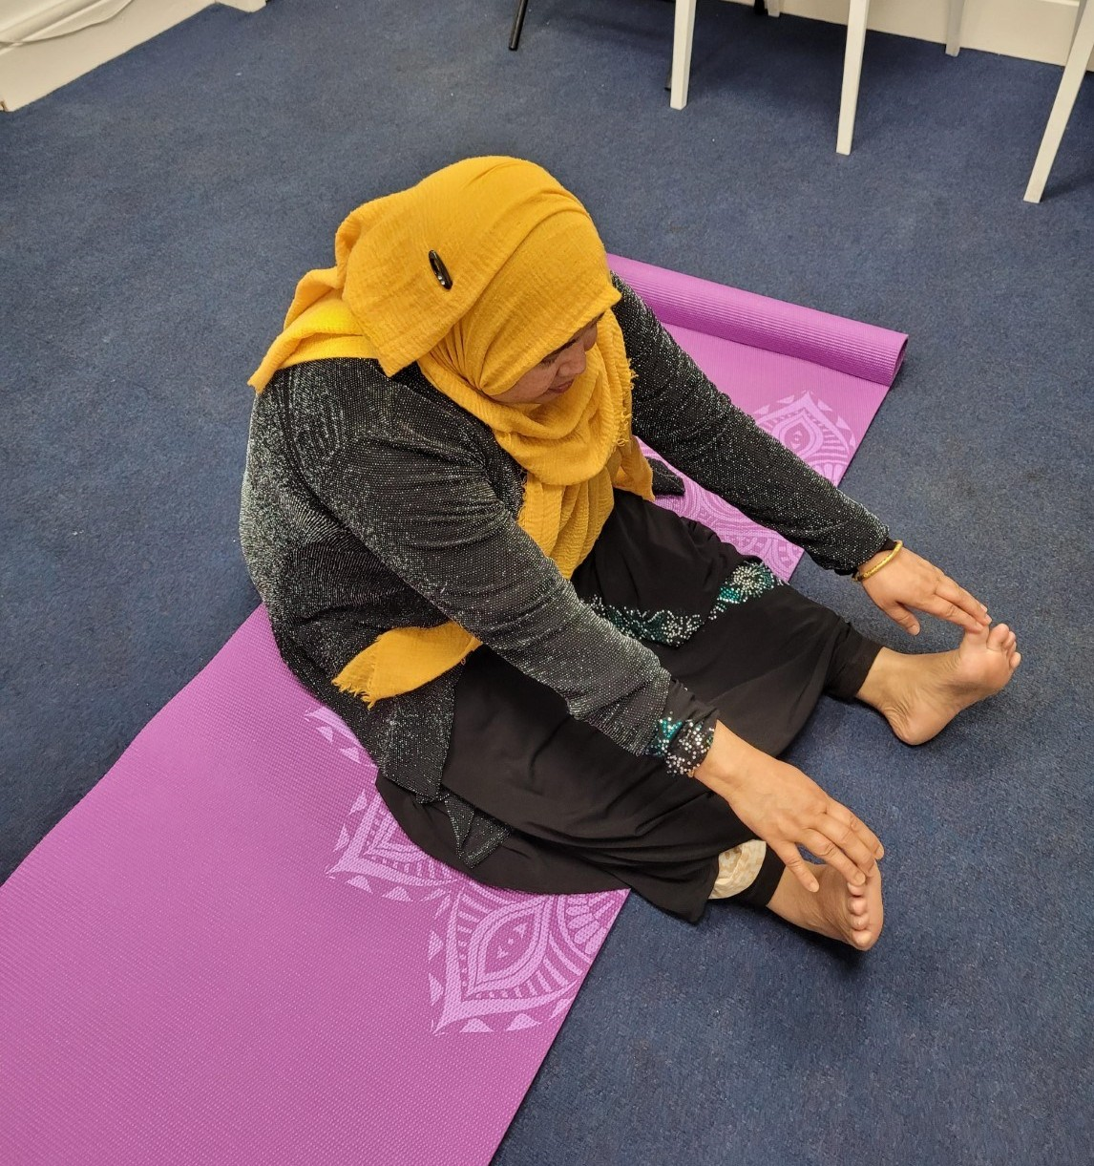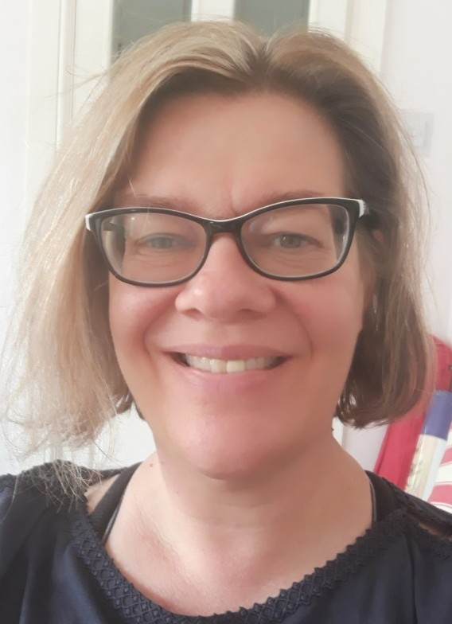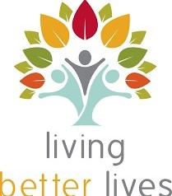

Caring for Carers

One of the focusses of the Asha Ki Kiran (Ray of Hope) project is to ‘Care for our Carers’. Support Worker Farida Ansari says: “Many women are caring for children or adults with disabilities or special needs within their home.” Farida explains that many of these women are unaware of the help and support available to them.
Apna Ghar started the support sessions by inviting Jacqui Kaid, Strategic Carers Liaison Officer,
who delivered information to a group of six women, who are carers for family members. Jacqui delivered the contents of the
Carers Handbook to the service users.
Farida Ansari explains: One of our carers was very astonished to know that there is help but she struggled so much with her first child. Her elder son has learning difficulties and
she struggled so much with him as she was new to this country and didn't know that she can get help. She is very pleased that she attends Carer sessions gaining knowledge about diﬀerent kinds of help
and benefits”.

One of the service users enjoys the benefits of Yoga in Apna Ghar
RELAXING BODY AND MIND WITH YOGA
Four blocks of 6 week Yoga sessions were held in the centre to help relieve stress, calm the mind and strengthen the muscles.
Yoga tutor, Patricia Uttridge delivered the sessions in Apna Ghar to groups of women who were keen to learn about the beneﬁts of yoga.
One of our service users said: ''My doctor advised me to get some exercise, I attended Apna Ghars Yoga class and it has helped me quite alot. I have also met other lovely ladies who are in the same boat as me.''

Level one carers achieve success
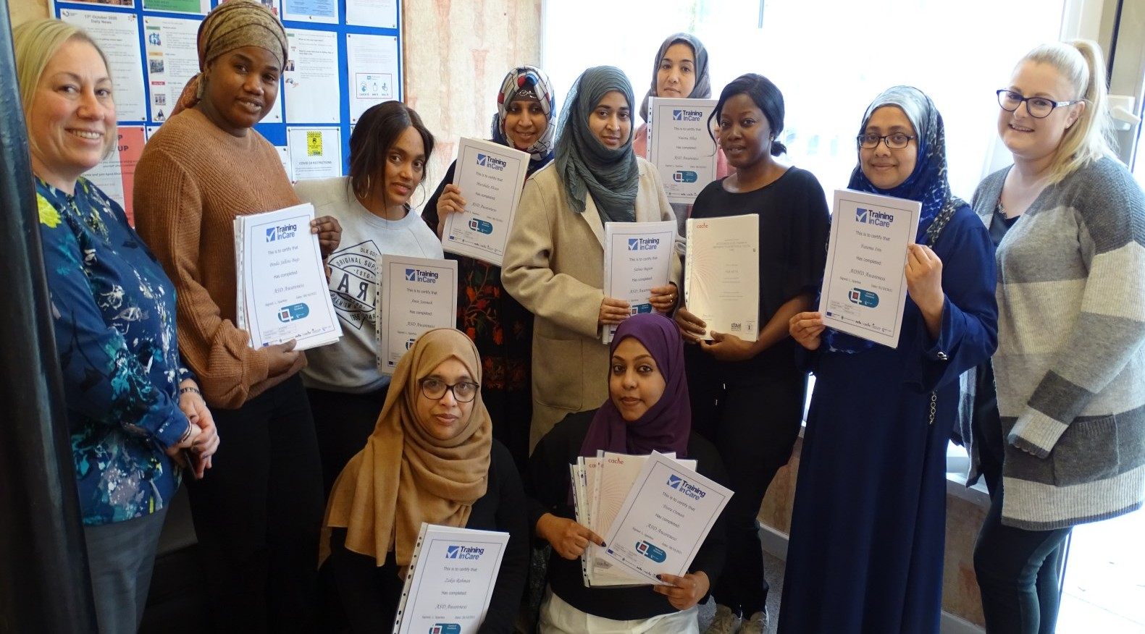

EXAM SUCCESS: All ten students (above) studying for their level one Adult and Child Carers certiﬁcate were happy to receive their certiﬁcates in July 2021.
Tutor, Natalie New (above right) said: “The group were all so proud of themselves, but also of each other as they realised that they could achieve a lot. They were all really keen to move onto higher levels and look into gaining employment in the care sector.”
Receiving her certificates, Fatema Irin
said: “I feel very proud. I am excited and very happy.”
As well as receiving their level one
certificates, the students also received awareness certificates for Dementia and Mental Health. Fatema Irin said she found the course very interesting. “I
learnt about Dementia and Mental Health. I learnt so many new things during level one,” says Fatema. Both Lynne and Natalie gave us lots of information about Adult Carers.

Homework club for Carer students

Apna Ghar responded to the Carer students needing time and space to devote to completing their homework by setting up a ‘Homework Club’.
On track
All thirteen students, who have been studying the 17 module Adult Care Diploma Level Two, have been described as being ‘on track’ by tutor Lynne Sparkes. “Level 2 Group tutor Lynne said, “Each and every one of the learners have stayed on programme throughout, a few have actually already completed and moved onto supporting others in the group to finish. They have all completed skills days to put their knowledge of what they have learned in the classroom, into practice. We are really proud of how far they have all come and are excited to see what they can
“
do in the future.”
A FEW HAVE ACTUALLY
ALREADY
COMPLETED AND MOVED ONTO SUPPORTING OTHERS IN
THE GROUP
TO FINISH
Students studying for their level one and level two certificates said that having the time at home to complete homework was very challenging. Apna Ghar formed a homework club for the students. One of the students, Rita Hossain said the homework session was very helpful. “Natalie [New] was very helpful and she helped everyone with their homework.” Rita explains that as a single mother she finds it very hard in the morning to do everything

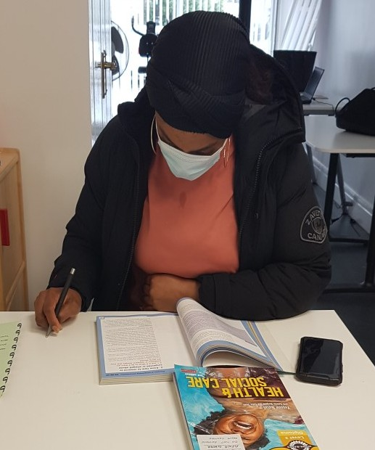
by herself and often misses her breakfast. She said, “I am very thankful to Apna Ghar for the lunch that they provided to everyone.
Without food it wouldn't be easy to stay all day. She enjoyed having lunch
with everyone and share the bonding.
Fatema Irin said homework
sessions was a great idea. In the beginning when she did her homework at home, she used to struggle a lot as there was no one at her house to help her, but when they started attending the homework session she was very happy as she could finish her homework the same day.
Fatema also said that Natalie was very helpful and supportive.
Projects Coordinator, Susan Stevenson said: “A big thank you to the
Training in Care staﬀ who adapted the sessions for the students and ensured that Natalie New was on hand to help the women complete their homework.”

Women Thrive with Luncheon

Lunch was back on the menu thanks to a partnership with WHiST and their Women's Thrive Project.
Since Apna Ghar was formed by its founder, Vimla Storey, more than 34 years ago, the luncheon club has been a place for women to meet, make friends, eat together and share stories.
Volunteer Lead Drupy Senanayake says: “We have ladies from many diﬀerent countries coming together cooking their own cuisine
and sharing recipes and this has made all the diﬀerence as we learn to eat and learn about the diﬀerent cultures
from around the world.” Drupy explains:
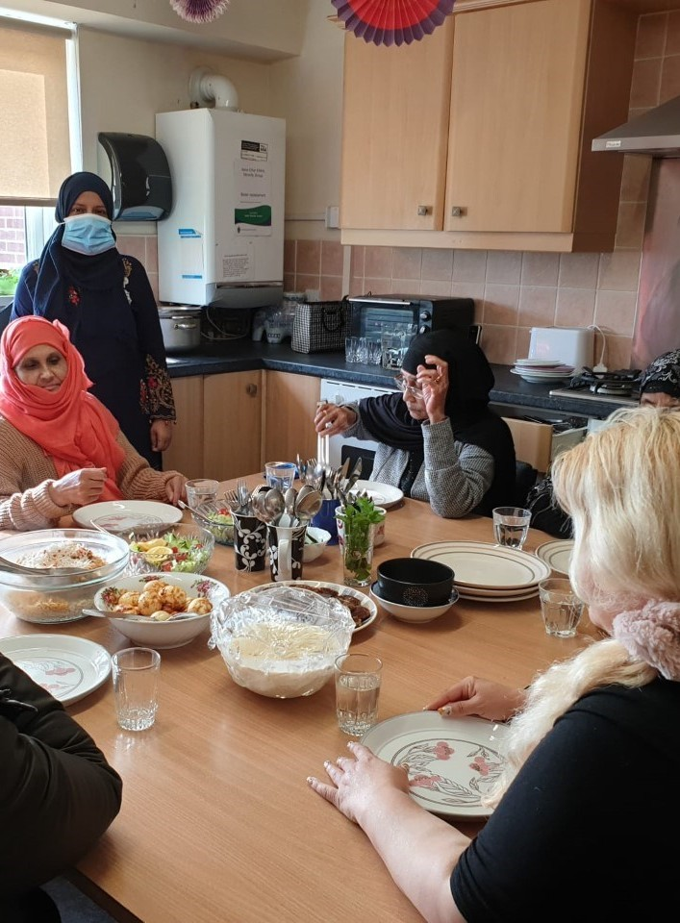“It is a place where a single mum or a lonely elderly lady who eats alone at home can come together once a week to have a diﬀerent meal.”
A group of ‘unpaid carers’ share lunch together in Apna Ghar
A few words that have described this club “I feel fulfilled and happy when I come and eat and talk to the ladies,” and “I miss the food when it's not on”.
For more information on the Luncheon Club, speak to a member of the Apna Ghar team.


“
“
I FEEL I HAVE A FAMILY TO EAT WITH WHEN
I COME HERE
Ladies Rise to get into fitness

Flu Jabs
As well as promoting the Covid 19 boosters, Apna Ghar again hosted ﬂu clinics in the centre ensuring more than 70 women got their annual ﬂu jabs. Service users were keen to come to the centre for their jabs. One service user said, “I prefer having my ﬂu jab at Apna Ghar as I know I will get help with language straight from the time I enter the door. All staﬀ are very helpful.”

Medical School Partnership
Over the past year, Apna Ghar has partnered with Sunderland University to give placement opportunities to a group of year two medical school students.
One of the students, Syeda Haque, who had a placement in the centre said:
“Thank you for your time and allowing me to shadow your team at Apna Ghar. It was incredibly insightful to be part of that. The community event you held for the Womens Together Partnership was greatly appreciated. I cannot tell you enough how much I learnt from everyone there.”
Eight students had placements in the centre and learned about the local community and spent time getting to know about the services available. This helped give the students an understanding of how much service provision takes place outside of primary and
secondary care and the diﬀering populations they may meet as future doctors.

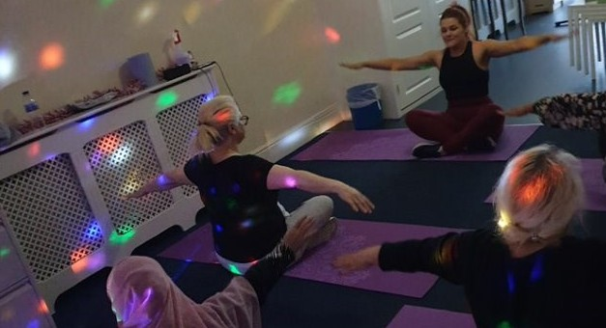
Thanks to the Rise Together Fund Apna Ghar Service Users have been able to take part in fitness classes, targeted towards women of all abilities. Circuit training, seated exercise, whatever the ability, it’s catered for. Toni Elwin delivers the course. Toni says: “The objective of the class is not only to increase fitness, but to do it in a fun and accessible way, this has been aided by the wonderful new equipment of resistance bands and exercise bikes.” Many of the service users have told Toni that the class has
encouraged them to continue exercising outside of the classes, many have done so by walking to the centre and performing the exercises at home. “I have intentionally made the class attainable to encourage this continuation at home,” adds Toni.
If you’d like to take part, speak to a member of the Apna Ghar team.
66

This popular class is sew good

Thanks to The National Lottery Community Fund, Apna Ghar were able to restart the Sewing Class
this year.
Sewing Tutor Anila Maqbool said: “The majority of the students, who started the class this term, were novice but very keen to learn the sewing skills and how to use a sewing machine. Mainly the reason for them to enrol on the course was for them
to be able to make their own clothes/garments, be able to do basic mending and understand diﬀerent types of fabric.
All students started with learning to use the sewing machines and discussed which one to buy for their personal use according to
their skill level. Students also
learned how to create a

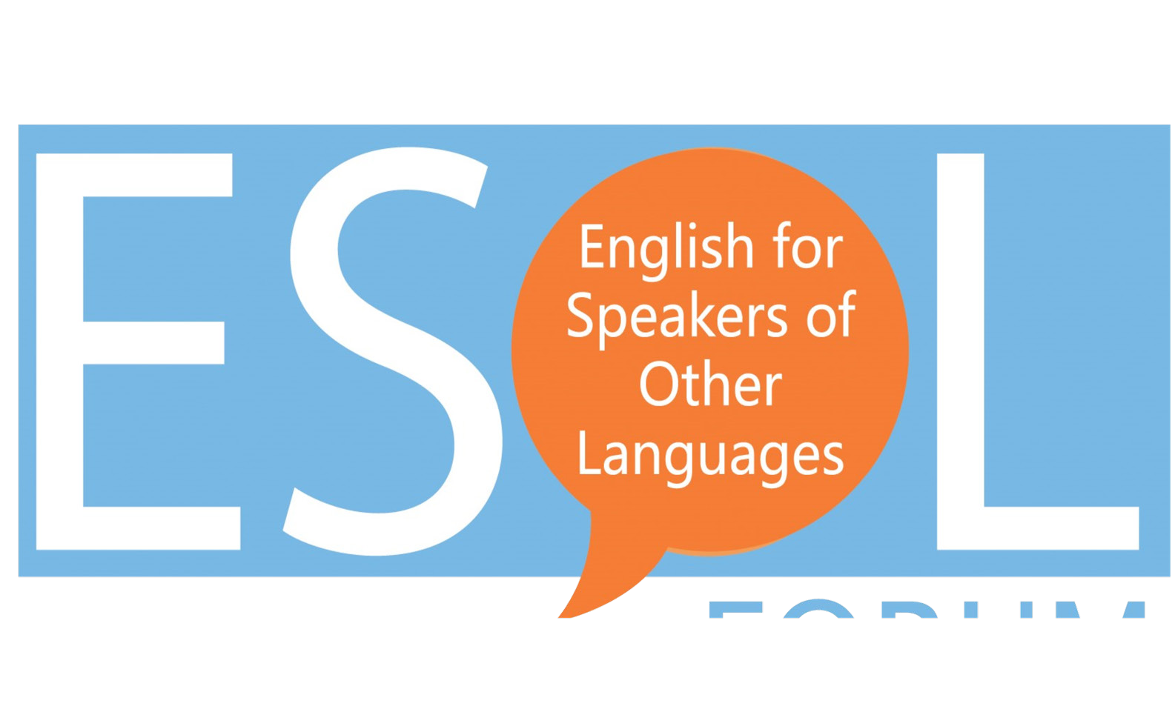“
THANK YOU APNA GHAR FOR
HELPING ME FIND MY PASSION [FOR SEWING]

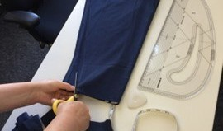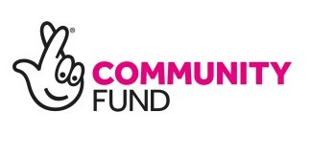sewing pattern using an old garment. Creating their own sewing pattern was preferred in order to enhance students’ Maths and English skills. This will also allow students to save money by not buying
NEW SKILLS: Student’s are learning skills to make their own garments and
discussed how they can create self-employment opportunities.
pre-printed patterns and will support their creative
thinking as they will be
able to make changes to

their patterns according to their needs.
Students have shown dedication to the learning throughout the course and completed many projects. Some of the students also discussed how can they use the newly learned sewing skills to create self- employment opportunities.”



ACHIEVING POTENTIAL
Apna Ghar has hosted a wide variety of classes and sessions to help build women’s confidence and guide them either into work, or into education over the last financial year.
Projects Coordinator Susan Stevenson says: “Working alongside agencies such as Northern Rights and Training in Care, women have been able to access a wide and varied range of classes and information sessions to help them.”
CV writing and application forms have featured highly on service users ‘need to know’ list. Northern Rights held an information session in the centre, giving women the opportunity to register with them for future help when applying for work. One of Apna Ghar’s service users, Rita Hossain says:
"I did my Adult Carers Level 2 course at Apna Ghar. This course was very interesting and useful. I need to do 150 hours placement to get my Certificate. Training in Care was very helpful and gave me all the information where and how to apply for the placement. Natalie who works for Training and care helped me to get a placement at Age Concern and I'm thankful to her. I am very thankful to Apna Ghar for giving me the opportunity to attend Adult Cares Level 2 which was funded by National lottery. A big thank you to National lottery too".
ESOL (English for Speakers of other languages) classes have been held in Apna Ghar by South Tyneside College over this year. Leyla AlSayadi has been delivering the course.
Leyla says: “The course overall was very successful with five learners passing
speaking and listening NOCN exams with a
minimum of ‘satisfactory achievement’.

This result has been internally and
externally verified. The learners were actively engaged in lessons and the positive group dynamic contributed to the progress made by each individual.
If learners can demonstrate commitment, I believe that next year holds even more opportunities for them as we change to the nationally recognised Trinity Exam board.”

Partnership working for IT Classes

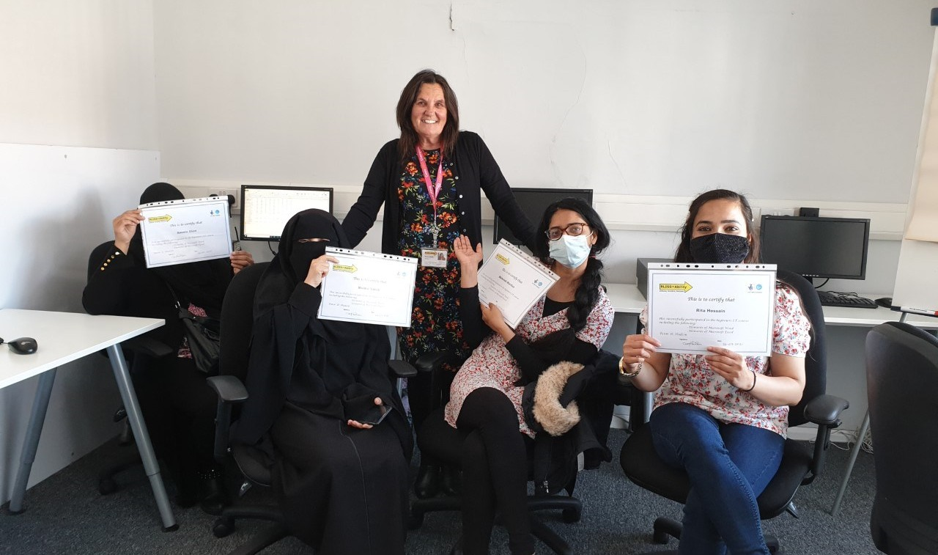Working in Partnership with local charity Bliss=Ability, IT sessions were delivered to service users in Apna Ghar.
A group of students receive their IT
Some of the women are pictured receiving their IT Participation Certificates. IT tutor, Doreen Hudson says: “They have worked hard and made excellent progress most of them having no previous knowledge of IT.
Some of them will be continuing their learning as this was a first step for them.
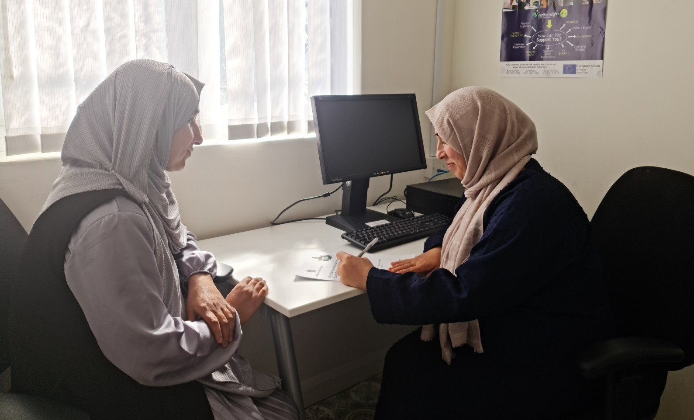
They have gained confidence in themselves and have taken great pride in their work and achievements. BLISS=Ability wishes them the very best in all their future ventures. Well done ladies.”
A SERVICE USER SAYS:

“I lost my husband a couple of years ago, and it is through Apna Ghar that I have started to gain my happiness again.
The support I
received over the years have built my self-esteem and confidence.
I attend English class and have improved my English
language skills.”

A lifeline for our service users

Family Support Worker Nasrin Begum reports on the delivery of the Information, Advice and Guidance (IAG) service: “Our engagements with our service users continue to increase and we are happy to report that over the year we have supported 127 clients. The main areas that we oﬀer support have been accessing GP appointments online, education, translating
letters/documents, immigration, benefit claims, social housing, council tax and Universal Credit.
Referrals come from Jobcentre Plus with the majority accessing our English classes to develop their language skills, which will help them to access jobs in the future. IAG is a lifeline for some of our service users. Many would struggle to engage due to language barriers and low self-esteem
and confidence, thus would not receive the help and support they require to get on with their daily lives.
“I am proud to be of service to improve the lives of these women. I would also like to add that Apna Ghar are grateful for the funding received from Coalfields Regeneration Trust this year, who have supported us to continue this invaluable work for our service users
and the BAME communities.”

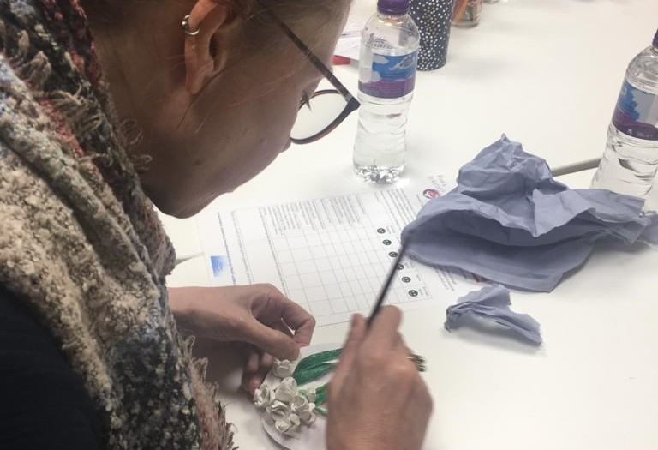A survivor’s story
ART THERAPY: Apna Ghar staﬀ have been raising awareness of Domestic Abuse through art sessions
- a story of hope


Support groups helping the survivors of Domestic Abuse
C
urrently, we have 52 clients in our database, 30 clients seek help each month through 1:1, domestic abuse group sessions, and are encouraged to attend classes and courses. Over the last
year, the Apna Sahara project has received 15 new Domestic Abuse referrals from external and internal agencies. The Apna Sahara project has provided information and guidance to external agencies working with youths around DA and signposted them to appropriate youth agencies.
We have given support around BAME and cultural abuse and supported
external professional around this issue and support.

Apna Ghar has worked in partnership with Sangini through the Women Together Partnership to raise awareness around domestic abuse and the importance of art and creative therapy in promoting positive mental
health and healing from trauma related abuse. A service user who attended the sessions stated, she wanted to speak to someone about
domestic abuse but was unsure and uncomfortable until this space was given to them to explore their feelings around domestic abuse.

Domestic Abuse Lead Raj Kaur says:

“We have had a busy and tempestuous year with the Apna Sahara project. It has seen many changes as we came to the end to our PCC funding for the project in October 2021. However, we have worked hard to maintain the support we had for our DA survivors by providing 1-1 Domestic Abuse emotional support, signposting to relevant agencies such as WHiST, Options, CREST, Impact, Changing Lives. Through the partnership work with Sangini, we have provided Domestic Abuse survivors with art therapy related support, which has a positive impact on the women. I am pleased to say that we have now secured additional three year funding from Northumbria Police and Crime Commission to continue to deliver this project.”
Domestic Abuse worker Farida Ansari shares a survivor’s story: Client A has been married for 12 years and she didn’t realise that she had been a Domestic Abuse victim for so many years. When she married, like any other girl, she had lots of hopes and dreams with the marriage. Her husband is a very
controlling and orthodox. He tried to
control her in every aspect of her
life. She realised he was not the right person from the beginning but she wanted to give a chance to her marriage with the hope that he might change one day.
Client A is going through depression and seeking medical help for it. She always wonders where to seek help for her problem because she knew the life that she has been living is not a normal life. One day she attended one of the Domestic abuse awareness sessions at Apna Ghar and learned about Domestic abuse and its types and also where to seek help. She was very happy that she attended the session and got all the information. Now she shares her problem with the Apna Ghar Domestic Abuse team and decided to move out of the abusive
relationship. She is very thankful to Apna Ghar and Comic Relief who have given hope to her and many other women within the BAME
culture who are suﬀering in silence.

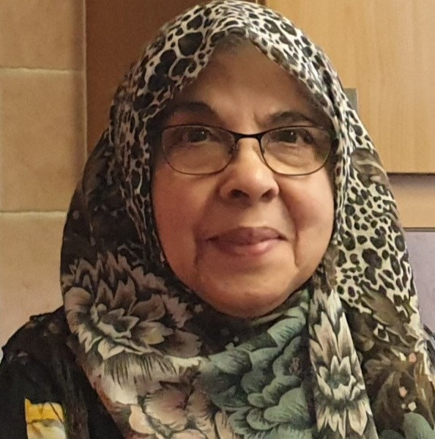
The
treasurer

reports

Apna Ghar’s Treasurer, Amina Hyder gives us a rundown of the charity’s ﬁnances for the year. Amina says:

Once again Apna Ghar is able to celebrate its success in providing services to the community through the continued support of our funders. I list below grants received from a number of sources:

£80177 from Comic Relief Fund working in partnership has been our major funder and helped us to maintain good control over expenditures throughout.

£38196 from the National Lottery Community Fund for our long-awaited carers project and a sewing class.

£10000 from Coalfields Regeneration Trust for our valuable Information Advice & Guidance sessions. £10000 from Garfield Weston received in March’21 will be carried over to the next financial year as part funding for our much-needed Domestic Abuse project.

£7628 from Northumbria Police and Crime Commission for our Domestic Abuse project
which is going from strength to strength. A welcome continuous award of
£5000 from the South Tyneside Council
to support our outreach work to the community.

£4000 Ballinger Trust has been very
supportive over the years and granted us
£4000.00 annually a contribution towards our running costs.

Few smaller grants were received -

- RISE North East for Fitness classes,
- Community Foundation
- S&T Grassroot Fund for refurbishment
and
- Women Health in ST for luncheon club

In conclusion I have to say the year ahead will be full of challenges as obtaining funding will be difficult but with the help of our dedicated staﬀ, volunteers and Management Committee we will continue to thrive. I would like to give our
thanks to all our funders without their support our work would not be possible. Thanks, are also due to Nasrin our Finance Officer for looking after our financial aﬀairs.

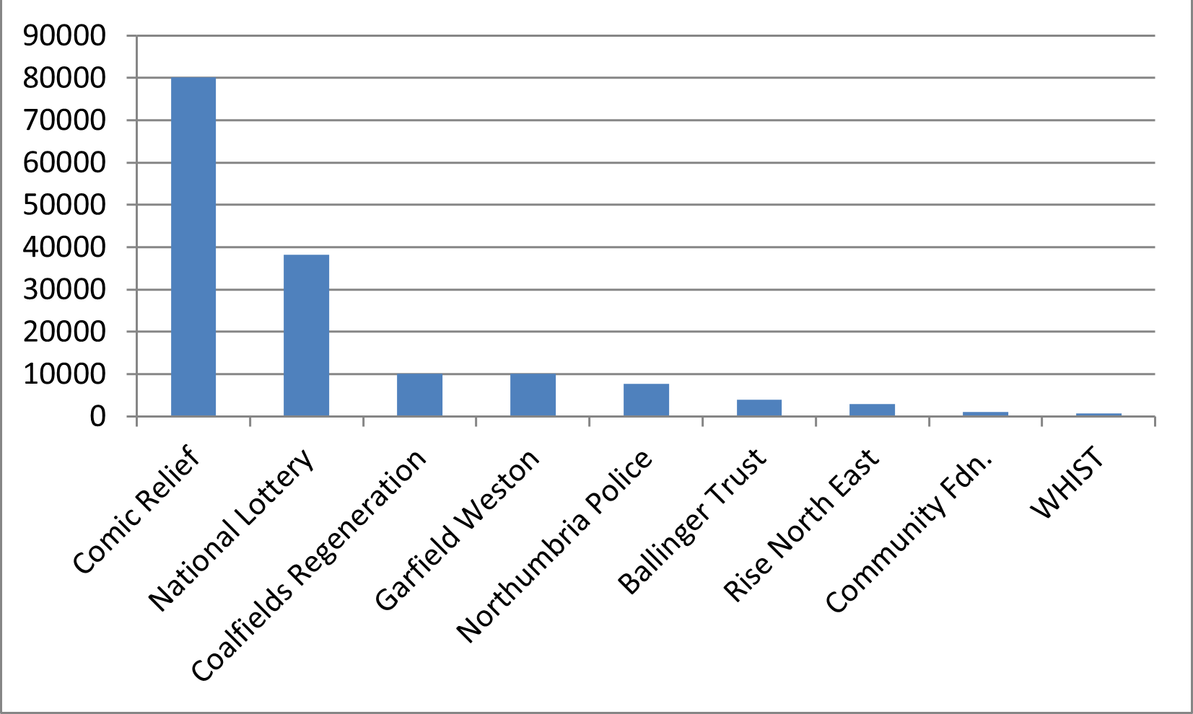What else?
As well as all of the funders listed, we also extend our thanks to many organisations for their support and guidance throughout the year, which is greatly
appreciated by Apna Ghar.

Our projects - 2021/22
Here is a summary of service users’ attendance at our classes and activities for the year...
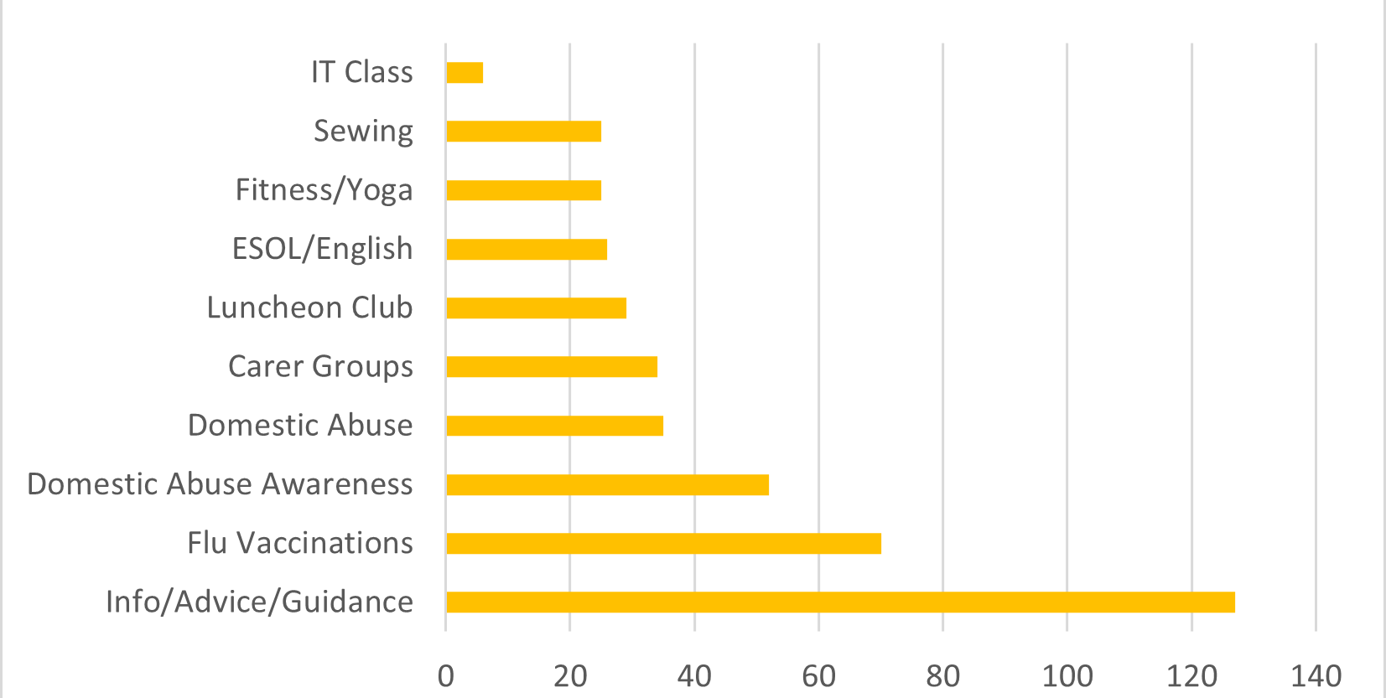

Ethnicity of members - 2021/22

Here is a summary of service users’ ethnicity ...
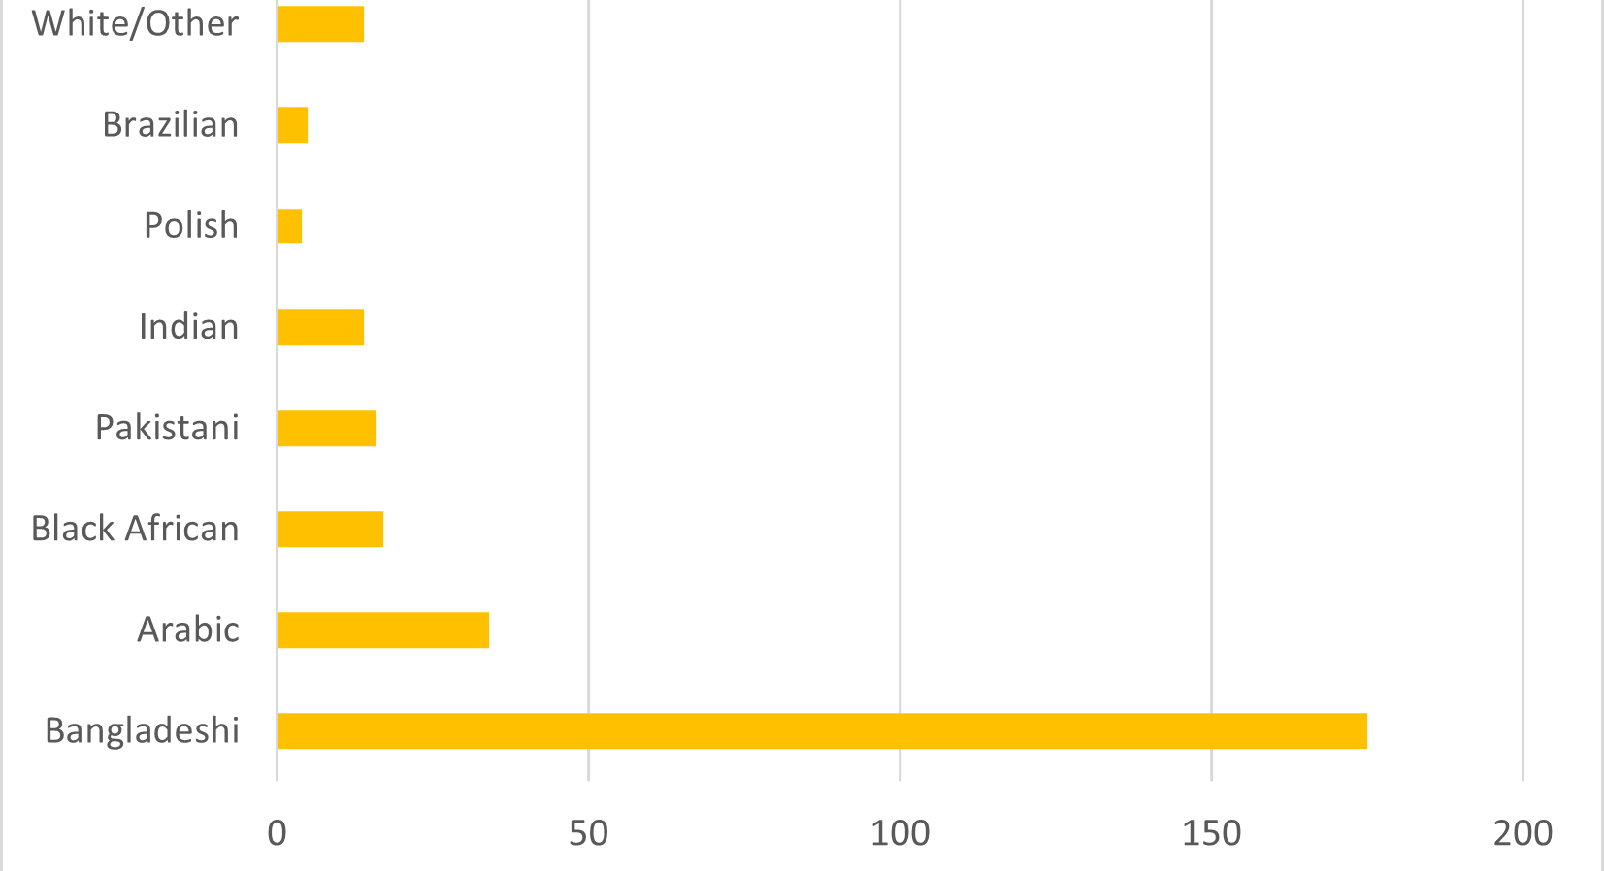

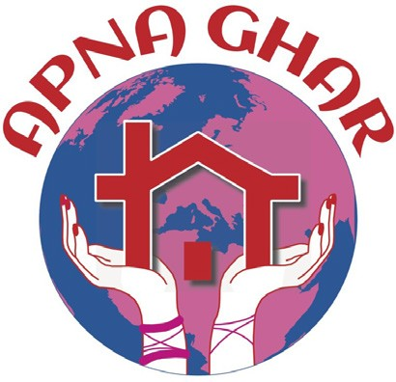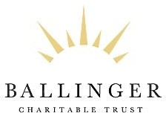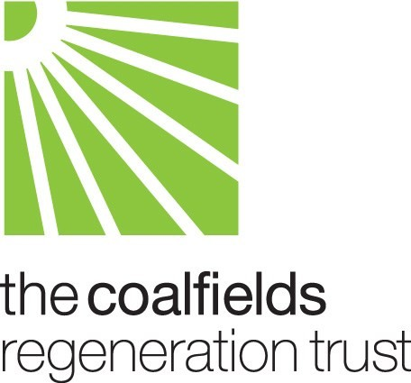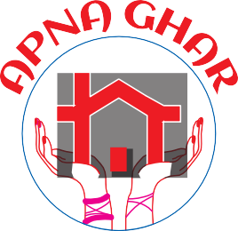
Acknowledgements

Apna Ghar Minority Ethnic Women’s Centre would like to thank all who have
supported them during the 2021/22 ﬁnancial year, including the following funders:

Apna Ghar Minority Ethnic Women’s Centre
124 - 126 Ocean Road South Shields Tyne & Wear
NE33 2JF

Tel: (0191) 456 4153
(0191) 456 4147

Email: ag@apnagharwomenscentre.com Website: www.apnagharwomenscentre.com

Registered Charity No.

